April 2021
GRENED Newsletter

Dear reader,

Greetings! And welcome to GRENED’s first newsletter for 2021!
This newsletter has been dormant for many quarters, but we are back! Our hope for 2021 is that we return to being published every quarter!
Congratulations that you as you our community, our family has all survived covid-19 so far! We are now extending our protection by taking a vaccine. One hundred percent guarantee against the disease is not given, but it certainly helps! Let us continue to wear protective personal coverings and practice safe protocols. Let us continue to be cautious yet resilient as we re-connect and rebuild our lives and economies.
Over the last year, GRENED has worked hard to respond to covid-19 in a manner that preserves GRENED’s programmes, relationships and economy. We too have been challenged— be we remained anchored in our commitment to educate the nation’s children and enable them to rise, to lead. During 2020, we closed the office for several months; we continued our scholarship though awards were cut in half, held personal development and leadership training seminars, assigned mentors and kept a schedule of academic support.
With the new year we continued all the above. In addition, we mobilised 39 students for a one-week training in swimming; we have continued preparation activities for two community resilience building projects and have started an anti-domestic violence radio series. We are revitalizing our board and we have continued to work with our sister organization GRENED USA INC in the USA.
All this was possible with your support, and we thank you for your time and money!
In this maiden 2021 newsletter, you will read about GRENED’s young people making their way in the world. Read their stories and see how happy, successful and service-oriented Grenada’s children can become! Please continue supporting them!
On July 16th this year GRENED will mark 25 years of its existence. Despite the setbacks of covid-19, we will celebrate.
You can continue to support us using our new feature – paypal on our website (www.grened.net); or come into our office on Upper Ben Jones Street in Grenville. Call us at 442 6277 or 423 5124. Facebook.
Thank you for placing your confidence in us and supporting Grenada’s best! and ---happy reading!

Dessima M. Williams
Director

GRENED STUDENT STARTS MED SCHOOL January 2021

Introducing Charmaine Joseph, a scholar, youth debater, youth ambassador, GRENED volunteer and intern, a long standing supporter of every activity initiated by GRENED and at present, Medical student at the St. George’s University, recaps her experience with GRENED.

Recognizing the ones who have made a positive impact in my life and who have helped me to reach thus far as a (Future) Medical Doctor has never been difficult.
The Grenada Education and Development Program (GRENED) never stopped showing up and showing out. Whether it was by organizing and executing the interesting Summer Science Projects, Public Speaking Sessions, Goal Setting Seminars or just simply having fund raisers, it was always an enjoyable time learning new things, growing as an individual and having mentors who truly cared about my personal, academic, financial and emotional well-being.
The countless support I have gotten throughout the years is immense and I am humbled and grateful to have such an amazing group standing by my side because I know it is genuine.
I can wholeheartedly say that I am not just part of an amazing organization but that I have found another family and for this I say thank you, GRENED.
Charmaine.

2021 swimmers: Grenada Learn to swim week
Academic Support and Leadership Development Sessions for Students

GRENED Newsletter
April 2021

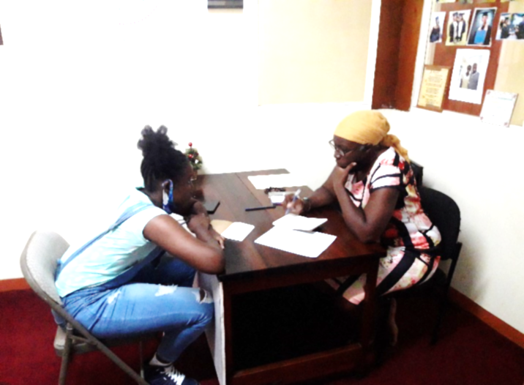
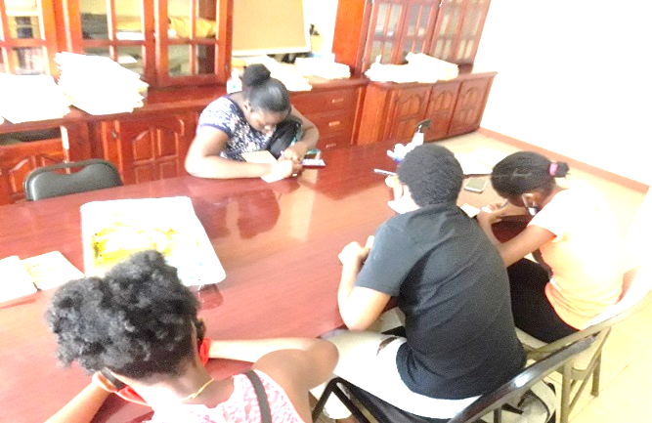
In order for GRENED students to continue to reach their full academic potential during this pandemic period, we have had face to face academic enrichment session with six (6) of our GRENED students, led by Ms. Vall Gordon, facilitator. Two sessions were done with the group and four sessions were with individuals. Without their classroom setting, students are experiencing many challenges and GRENED is ensuring sure that they all keep up with their academics. During these sessions students are being engaged in identifying different learning styles; how to breakdown assignments to their simplest parts; how to separate facts from opinions; how to Identify problem areas; how to state the problems and how to identify and apply solutions. Ms. Gordon is now working on the design of a system with them to solve similar problems; goal setting so as to improve grades and is designing an accountability system to help with goal achievement.
Students with their face to face individual sessions January 2021
The tools given to student by Ms. Gordon as facilitator appears to be working. We observe changes of a more confident body language in many students. Also, two have transitioned into the larger group session on communications and self-expression with facilitator, Ms. Abena Vincent, teacher, St. Joseph’s Convent, Grenville.*
Student at her face to face individual sessions
March 2021

Every first and last Saturday of each month students gather at the St. Joseph’s Convent, Grenville for sessions on personal development (“Who am I?”), public speaking, conflict management and goal setting.
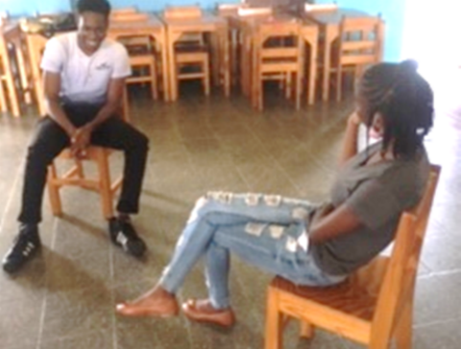
For the students to become service-leaders rather than only have high academic averages, they are trained to learn to communicate, have conversations, etiquette, make choices and so on. These Saturday sessions are with Ms. Abena Vincent. Other leadership sessions in May 2021 will be with professionals in different fields.*
Two students’ role playing on different scenarios given by facilitator
GRENED Newsletter
April 2021

My journey with GRENED began after I passed my common entrance examinations many years ago. I know many others have a similar story as me. However, the GRENED experience changed my life for the better. Being associated with GRENED, I learnt many positive lessons
and I want to share three of those lessons with you.

Lesson 1- Always Go Above and Beyond (DO MORE)
GRENED scholarship programme provided me with the necessary resources to make my educational journey comfortable, my family never had to worry about books, uniform, bags, etc and that in itself is sufficient for any scholarship programme. As a matter of fact, I know that many programmes that are similar in nature, stop at providing those things. However, with GRENED, that was not the case. The organization not only invested in my formal education but in my overall development as an individual. The doors were open to me on a daily basis, the computers were available for me to use, as a matter of fact, I did the majority of my student-based assessment, SBAs, at the then GRENED office in Telescope. My first encounter with programmes like Microsoft Powerpoint was when GRENED paid for me to take a course at Computer Visioners in Grenville and the first and only typing lesson I took was in the GRENED office. After I had completed my secondary education and went on to college at TAMCC, the team at GRENED assisted me in applying for a government grant to help finance my college education. I got the grant. GRENED was very helpful in the application process for my scholarship to attend university as well. Now, I take a page from GRENED’s book and I always try to do MORE. I figured since GRENED could have done so much for me when they didn't have to then I can do the same for others and that feeling of always doing more has been the driving force behind my success in life. I graduated with a Masters Degree in Digital Media two years ago, I graduated top of my class. From the first day I set foot in the university, I pledged to myself that no matter what, I will do more, more than my classmates, more that is expected of me in class and that has paid off. Thank you GRENED for instilling “the DO MORE” culture in me.
Kimron Corion, former GRENED Scholar, now Head of Communications, Grenada Tourism Authority. Social Media Strategist, Creator of on-line, I am Grenadian.
_______________________________
_

Lesson 2- Trust The Process
There were many times during my time with GRENED I will question why we always had to go to personal development sessions or question why I have to wake up on Saturdays and attend events at Rainbow Inn or at the Office. But I did it anyway. I believed in the GRENED team and I said to myself, if they said its necessary then it must be. So I ultimately trusted the process and I was right.

GRENED Newsletter
April 2021

My development not just as a student but as a person has been largely shaped by GRENED. When I first came to GRENED, you couldn't get me to talk in public for anything! I was beyond shy, Mrs. Teague, Dr. Williams and Ms. Williams can testify to that. They had to keep pushing me to even speak. By the end of my time with them, I was one of the most outspoken scholars during my time. Today, I am an entrepreneur and public speaking is a huge part of my business. I have spoken at events and workshops in Grenada, Canada, Trinidad and Tobago, as a matter of fact, last November I spoke at the Caribbean Entrepreneurship Summit and next week, I will be teaching a master class on Social Media marketing here in Grenada. The first time I ever spoke in public was as a Scholar right here at GRENED. So my advice to you is to trust the process, you never know what is in store for you. The skills they are teaching you today may be the one thing that will largely be responsible for your success later on.

Lesson 3- Have Faith

My experience in GRENED was largely guided by faith: they had faith in me to take a chance on me and I had faith in them to help me get through Secondary School. But beyond that, it was an atmosphere that was driven by faith in God that really got to me, just sitting back and experience people like Mrs. Teague and Ms. William exercise their faith in God helped me come to terms with my own faith in God and that has been the primary driving force of my success. When I started my Master's degree in Canada, I had no idea how I was going to pay my tuition, I just had faith something was going to work out. I started school and three weeks in, I got a call from my programme director saying that I was going to be receiving an Ontario Graduate Fellowship, something for which I did not apply. The fellowship was enough to cover my tuition and I know for sure, that this was nothing but God rewarding me for my faith in Him, something I observed as a very young age being around the GRENED team.
Kimron
UPCOMING

Training Seminars
- Climate Change
- Bio Diversity
- SDGs
- Leadership Development

GRENED’s 25th Anniversary:
- July 16th 2021

ONGOING
- Fundraising—Please DONATE!
- Scholarship Awards and personal / leadership seminars
- Scholarship Reviews

Support / Volunteer
- For ICT/website Manager, mentors, programme planners, event coordinators.
- Inform others about us
www.grened.net

Photo Gallery with the Board of Directors engaging with GRENED parents & students

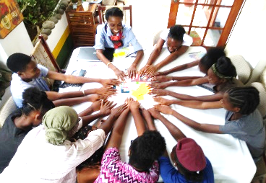
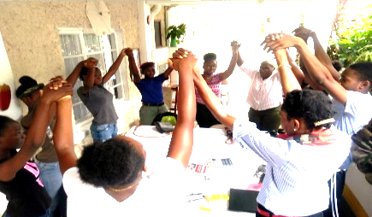

Some students spend the day with the Executive Director and Academic Enrichment Officer Vall Gordon: Facilitator

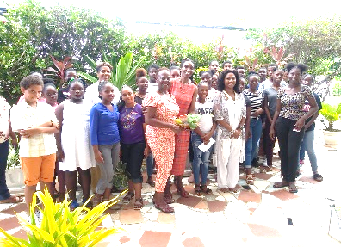
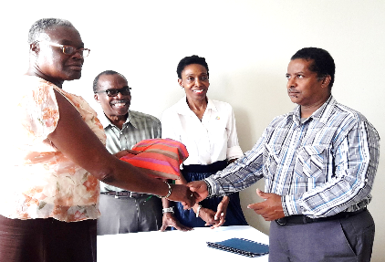

Board members with Representative from SAASS at the awards.
Students at a Leadership Seminars

GRENED Newsletter
April 2021
FIRST QUARTER 2021 DEVELOPMENTS

GRENED has undertaken two projects this year; “V” has no place in my home, an anti-domestic violence radio campaign. This is a national outreach project intended to raise national consciousness in Grenada of domestic/family and sexual abuse in Grenada, especially of girls and women, and it targets the possibility of increase in domestic violence due to covid-19 job losses, lock-down and other financial and social losses and restrictions. Indeed, initial data suggests that this cluster of crimes has worsened during the economic and social pressures of the corona pandemic, especially due to the loss of jobs and economic power of women, the requirement to shelter in place and other losses and restrictions on movements. The main objectives and results we intend to achieve are:

P
R
O
J
E
C
T
S
- To heighten awareness in homes and communities of the possibility of violence against girls and
women; to build confidence and ability to take safe action on the part of girls and women facing violence and potentially violent situations especially in the home; to provide knowhow to family members on diffusing violent situations in the home; and to increase the voice and capacity of GRENED in responding to violence against girls and women.
A 5-part audio was disseminated to five radio stations in Grenada and Carriacou and on social media: via Facebook and GRENED’s webpage. We anticipate broadcast to start April 28th for up to 10 days with active monitoring during and after as part of the monitoring for impact. Lead coordinator for this project is Ms. Hyacinth Mae Skervin of GRENED.
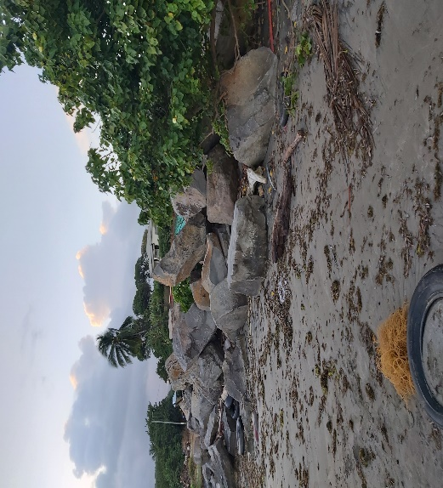
A second project getting started is “Strengthening Community Disaster Resilience”, being conducted in Telescope, St. Andrew’s. This project took place under the auspices of the Caribbean Natural Resource Insititue, CANARI, as lead sponsor and the Inter-American Foundation as funder. The CSOs for Disaster Resilience project., Telescope, St. Andrew’s, considers that area high risk because it is a low-lying coastal community located in Grenada’s north eastern coast. The community’s economy has historically depended heavily on the natural resources of fishing and coastal farming, leading to problems with effective conservation and management of these and other natural resources. Telescope has deteriorated significantly over the years due to erosion and other natural processes as well as human behaviour, e.g. sand mining. The objective for this project includes: raising awareness and mobilising key stakeholder to participate in planning activities in that community; conducting vulnerability and capacity assessment activities and analysing the results; sharing vulnerability assessment results and conducting disaster risk reduction planning with the targeted community. All this, in preparation of a wider response. This initiative is led by Mrs. Gloria Thomas-Samuels of GRENED.
Telescope beach area

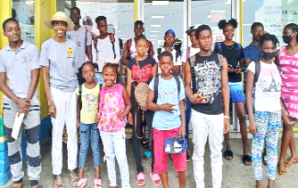
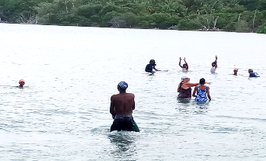

39 students in the “Get Grenada Swimming” PROGRAMME 2021

“Get Grenada Swimming” is an initiative to teach children to swim by offering free lessons for five days throughout the island. GRENED partnered with The Grenada Youth Adventurers to support this initiative. 39 students registered with GRENED to attend the programme. For most it was a fun learning experience. “I learnt to float for the first time and I had a great time and couldn’t stop talking about it with my family,” explained Desire Noel 7, one of our youngest swimmer and first time attendee in the programme. “Every day was a story”, responded her mother. Students and parents were grateful for the opportunity to attend.
Swimming participants with Executive Director of GRENED (in straw hat) and Get Grenada Swimming Leader, Deb Eastwood (in red cap)
GRENED, what does this name mean? To me it means a place where love is found, where I make new friends, get to develop a keen mind-set, learnt to speak up, attended various educational seminars, and received the opportunity to have an internship within their organization.
My years in GRENED allowed me to develop into the person I am today. GRENED has taught me so many things that I now use in my everyday life. As a young teenager growing up I was afraid to do so many things but because of GRENED I am able to do Public speaking, take up leadership roles, engage with other people and even encouraging others. This was clearly seen during my training period at the Royal Grenada Police Force Fire Department.
I was captain of the Volleyball team at the St. Joseph’s Convent Grenville for 3 years, a floor member of the St. Andrew’s North East Constituency Youth Arm, and now I capitalize on various opportunities to speak to large or small audiences and engage in small conversation with new people. The public speaking trainings from GRENED allowed me to become a more influential person. Financial support was also given and it helped immensely during my Secondary education where I obtained 9 CXC subjects and at the T.A Marryshow Community College where I obtained a Level 2 Certificate in General Office Administration.
I was welcomed into the GRENED family. They motivated, encouraged and helped me fight through my fears. I am very grateful for their role in my life’s development thus far.
--- Marisol Joseph
TAMCC Student
Pursuing an Associate Degree in ICT

GRENED
Grenada Education and Development Programme

Located on Victoria St. Grenville, St. Andrew’s (Upstairs SHOES R US).
P.O. Box 923, Grenville, St. Andrew’s.

Contact:
442 6277 or 423 5124
Email: contactgrened@gmail.com
Website: www.grened.net
Facebook: GRENED Grenada.

“A catalyst for empowerment, leadership and sustainable development through education.”

GRENED Newsletter
April 2021

Swimming participants with Executive Director of GRENED (in straw hat) and Get Grenada Swimming Leader, Deb Eastwood (in red cap)

